System: Payroll system, DTR and Staff Management system

Company/Office: Mart’s Minimart

Project Stage: Analysis and Logical

Date: November 14, 2023

Class & Section: BSIT - 3B

Group Name: Group 15

Group Members: John Rey J. Silverio Id Num: 59825696 Leader

John Matthew Morillo Id Num: 59826991

**Table of Contents**

1. Requirement Phase …………………………………………………………… 4 - 10
   1. Introduction …………………………………………………………………… 4 - 5
   2. Current System Overview …………………………………………………… 5 - 8
   3. Identified Risks …………………………………………………………… 9
   4. User Requirements …………………………………………………………… 10
      1. Functional Requirements …………………………………………… 10
      2. Nonfunctional Requirements …………………………………………… 10
2. Specification Phase …………………………………………………………… 11
   1. System Overview of the Proposed System …………………………………… 11 - 12
   2. Capabilities and Limitation of the Proposed System …………………………… 13 - 14
   3. Hardware and Software Specification …………………………………… 14 - 17
      1. Hardware Specification …………………………………………… 14 - 15
      2. Software Specification …………………………………………… 15
      3. User Specification0020 …………………………………………… 15 - 16
      4. Identified User Views …………………………………………………… 17
   4. Conceptual Database Design …………………………………………………… 18
3. Logical Database Design …………………………………………………………… 19
   1. Final Output Screen …………………………………………………… 19 - 27
   2. Final ERD Model …………………………………………………… 28
   3. Final Data Dictionary …………………………………………………… 29 - 34
   4. Final Normalized Tables …………………………………………… 35
4. Physical Database Design …………………………………………………………… 36
   1. Indexes …………………………………………………………… 36
   2. Integrity Constrains …………………………………………………… 37
   3. Transaction Map …………………………………………………… 38
5. Curriculum Vitae …………………………………………………………………… 39 - 40
6. **Requirement Phase**

**Introduction**

Mart’s Minimart is a wholesale/retail store where customers can buy products for their consumption or for their business. At Mart's Minimart, customers have access to a wide range of products, from groceries and household items to office supplies and beverages. The store prides itself on providing high-quality products at affordable prices, making it a go-to destination for both individuals and businesses alike. With a convenient location at P1-B, Sitio Maag, Samal, Island Garden City of Samal, 8119 Davao del Norte, and a friendly, knowledgeable staff, Mart's Minimart offers a one-stop shopping experience for all of its customers' needs. Whether you're stocking up on essentials for your home or outfitting your business, Mart's Minimart has everything you need to succeed. Mart's Minimart provides great customer service in addition to its large product variety. The staff is well-trained and educated about the things they sell, and they are always willing to assist customers in locating what they require or answering any questions they may have. Mart's Minimart is dedicated to giving all of its customers a pleasant shopping experience. The store is clean, organized, and well-kept, so customers can simply find what they need and feel at ease while shopping. Mart's Minimart promotes safety as well, enforcing tight rules to protect both consumers and employees. Overall, Mart's Minimart is a dependable and trustworthy shopping place for all of your needs. Mart's Minimart provides everything you need to make your life easier and more convenient, whether you're a busy professional, a small company owner, or a busy parent.

Mart’s Minimart has been open for the past 3 years with a promising point-of-sale system. The point of sale, often known as the POS, is where and when a retail transaction is completed. The merchant determines the customer's balance at the point of sale, notifies them of it, may generate an invoice for them, and provides them with choices for payment. The only thing that the Mart's Minimart's POS is lacking a payroll system. We have discovered that their owner and manager use a spreadsheet to record and determine the salary of each employee. Instead of using a spreadsheet, we proposed creating a payroll system within their POS. A payroll system is an on-premises or cloud-based solution for managing, maintaining, and automating employee payments. Payroll software that is robust, integrated, and properly designed may help businesses of all sizes stay in compliance with tax laws and other financial rules while also lowering costs.

**Current System Overview**

The present management employs the following systems:

Daily Time Record: The manager manually records the DTR of each employee using Microsoft Excel to compute the total number of hours the employee worked, which can cause a problem because of a human error.

The current Daily Time Record system records the DTR of each employee manually. A DTR's objective is to keep an accurate record of an employee's attendance and hours worked, which is beneficial to both the company and the employee. To compute payroll, assess employee performance, and assure compliance with labor laws and regulations, the employer must track employee hours. The employee, on the other hand, must track their hours to ensure they are properly paid and to provide documentation in the event of a dispute or legal concerns. One of the primary drawbacks of a manual daily time record is the possibility of errors and inconsistencies. When employees are responsible for manually inputting their hours worked, problems due to human error or purposeful falsification are more likely. This might result in difficulties like overpayment, underpayment, or disagreements about hours worked, which can be time-consuming and expensive to settle. A manual daily time record also imposes an administrative load on managers and HR professionals. Collecting, validating, and processing paper-based time sheets can be a time-consuming and labor-intensive activity, especially in larger firms with a significant number of employees. This can detract from other critical duties and lead to workplace inefficiencies. Manual daily time recordings can potentially be lost or damaged. Paper-based records can be misplaced, stolen, or damaged, resulting in data loss and mistakes in payroll and attendance records. This can be especially troublesome during an audit or legal dispute, where correct records are crucial. Finally, manual daily time records may be less handy or versatile than digital or automated solutions. Employees must physically be present to clock in and out with manual records, which can be difficult for remote or off-site personnel. Automated systems, on the other hand, can provide greater flexibility and convenience by allowing employees to record their hours in real-time from any place.

Mart’s Minimart does not have a payroll system, which is important for business owners and managers. A payroll system is a software application or system that organizations use to manage and automate the payroll process. The system is intended to assist businesses in calculating and processing employee paychecks, which include deductions, taxes, and other payroll-related charges. Payroll systems often incorporate features and functionality such as time and attendance tracking, direct deposit, tax filing and reporting, and benefit administration. Other HR or accounting software, such as personnel records management or general ledger systems, may also be integrated with the system. A payroll system's major objective is to speed up the payroll procedure and decrease the time and effort needed to handle employee payments. Businesses can save time and money, decrease the chance of errors, increase accuracy overall, and ensure compliance with tax rules and regulations by automating many of the procedures associated with payroll processing. Any size of organization, from small start-ups to major corporations with hundreds or thousands of employees, may use a payroll system. The system can be tailored to match the unique demands of the business, such as local tax rules, payment options, or reporting requirements, and it can be hosted on-premises or in the cloud.

Mart’s Minimart also does not have an account management system. An account management system's principal function is to manage and preserve employee data and information in one place. This approach aids organizations in streamlining their HR procedures, increasing productivity, and lowering the possibility of mistakes brought on by manual record-keeping. The system is made to store and arrange employee information such as names, positions held, employment status, salaries, and benefits. Businesses can quickly access and manage employee data by putting it in one single area, which can save access time and increase accuracy. Account management systems can contain functionality that allows firms to track employee time and attendance. This can help organizations compute employee pay accurately, evaluate staff performance, and manage scheduling. The system can also be used to manage employee benefits like healthcare, retirement programs, and other perks. Furthermore, the system can be coupled with payroll processing systems to ensure that employee wages are paid accurately and on time. Businesses can benefit from an account management system by streamlining HR operations such as onboarding, offboarding, and performance management. Businesses may save time, eliminate errors, and increase the overall effectiveness of their HR operations by automating many of these activities. Finally, account management systems can assist organizations in adhering to labor laws and regulations. Businesses can limit the risk of penalties and fines connected with noncompliance by tracking personnel data and maintaining proper records.

Overall, these three systems work together to ensure accurate and timely payment of employee wages while streamlining HR processes and enhancing efficiency. Businesses may reduce the risk of errors and increase the accuracy and efficiency of their HR operations by automating the payroll process and centralizing employee data. Wage payment accuracy and timeliness are critical to establishing a strong relationship with employees and can help to increase employee morale and retention.

**Identified Risk**

There are several risks associated with manual daily time records, payroll systems, and no-account management systems.

* **Human error**, such as forgetting to check in or out, misreading the time, or failing to record missing punches, it is not possible to precisely record the hours worked by employees.
* **Incorrect timekeeping**, such as failing to account for food and rest intervals or underestimating overtime.
* **Employee falsification of records**, such as checking in or out on someone else's behalf or reporting the wrong number of hours worked.
* **A lack of documentation of absences or leave requests**, for example, can cause confusion and possible disagreements.
* **Incorrect salary computations**, such as those that fail to account for deductions, overtime pay, or regular pay.
* **Late payment due to due clerical error**, such as inaccurate bank information or missing information on employee records, payments may be late or missed entirely.
* **Falsification of documents**, such as overstating expense reports or documenting hours that were not actually worked.
* **Data loss**, a record of that week may be accidentally deleted.
* **Inefficiency**, manual computing of DTR and Payroll can be time-consuming and inefficient.

**User Requirements**

**Function Requirements**

* The system will record DTR
* The system will accurately calculate a Payroll System
* The system will let the manager or HR to manage user accounts
* The system can view the employee’s account
* The system will allow the employees to file a report of any missing DTR or incomplete DTR
* The system will display the breakdown computation of the total net income of the employee
* The system will let the manager or HR to resolve a report DTR
* The system will display the employees allocated salary rate
* The system can let the user see his/her DTR and Pay Slip
* The system will receive a DTR report

**Non-Function Requirements**

* User-friendly interface
* Accuracy
* Speed and efficiency
* Reliable to Use

1. **Specification Phase**

**System Overview of the Proposed System**

The suggested system is a sophisticated and complete solution designed to automate the Mart’s Minimart daily time record (DTR), payroll processing, and employee account management activities. The system will include a user-friendly interface accessible via an application-based platform, as well as a variety of features geared toward optimizing HR operations and improving the employee experience.

The DTR module is a vital aspect of the system that will automate the attendance tracking process, removing the need for manual data entry and reducing errors. Employees will be able to log in and examine their attendance records, including work schedules, and time off, using the DTR module. This will aid in increasing employee engagement and ensuring that employees are always aware of their attendance status.

The proposed system's payroll system component will interact with the DTR module and automate the payroll processing function. Based on preset rules and regulations, the system will calculate employee pay, taxes, and deductions. The payroll system will also be able to interact with accounting software to ensure that employee wages are paid accurately and on time. The system will automatically generate pay stubs, reports, and other HR-related papers that may be accessed and shared by authorized individuals.

The proposed system will feature an employee account management module in addition to the DTR and payroll system elements. Employee account management will be a comprehensive system that will enable HR managers to handle employee records such as personal information, benefits, and performance reports. The system will serve as a consolidated repository for employee data, ensuring that it is correct, up to date, and secure.

HR administrators will be able to create and maintain employee profiles, allocate benefits, and other HR-related information using the employee account management module. The system will also have an alert and notification feature to help HR administrators and managers keep track of critical HR indicators, including employee attendance, overtime, and leave balances. This will help ensure that the HR team is aware of any concerns that require immediate attention.

In addition, the proposed system will include a reporting component that will provide a variety of HR-related reports, such as attendance reports, payroll reports, and employee performance reviews. These reports can be tailored to the organization's specific requirements and will offer HR administrators insights into critical HR KPIs, allowing them to make data-driven choices.

Furthermore, the planned system will be built with security in mind. To maintain the security and confidentiality of employee data, the system will include strict access controls and data encryption. The solution will also adhere to data protection legislation and industry norms, giving HR administrators and employees alike peace of mind.

Overall, the suggested Payroll Management System is a sophisticated and complete solution that would aid Mart’s Minimart in streamlining HR operations and improving employee satisfaction. The system's user-friendly design, extensive capabilities, and rigorous security will assist firms in swiftly and effectively achieving their HR and business goals.

**Capabilities and Limitations of the Proposed System**

The suggested Payroll Management System has numerous features and constraints that should be considered before implementing it in an organization.

Capabilities:

* Automation of DTR: Automation of DTR is one of the suggested system's primary capabilities. Employees will be able to log in and view their attendance records, work schedules, and leave balances using this service. Organizations can save time and costs by automating this process while also decreasing inaccuracies in attendance tracking.
* Automated Payroll Generation: The system seamlessly integrates with the DTR module, automatically generating payroll for specified dates. It calculates employee compensation, taxes, and deductions according to preset rules, producing pay stubs and HR documentation effortlessly.
* Employee Account Management: An employee account management module will be included in the system, allowing HR managers to handle employee records such as personal information, benefits, and performance reports. The system will serve as a consolidated repository for employee data, ensuring that it is correct, up to date, and secure.
* Ticket-Based Reporting: Users can easily submit DTR-related tickets through the system, streamlining the reporting process for efficient tracking and resolution.
* Security: Our system prioritizes employee data security with strong access controls, limiting account access to a single unit for enhanced protection.

Limitation:

* Training: Employees will need to be trained on how to use the suggested system efficiently. This may necessitate more time and money to ensure that personnel feel at ease and proficient with the system.
* Maintenance and improvements will be required on an ongoing basis to guarantee that the system remains current and functional. When deciding whether to use the system, the expenses of maintenance and updates should be factored in.
* Data compatibility: The proposed solution must be compatible with the organization's existing HR and accounting applications. Compatibility difficulties may emerge, affecting the system's functionality.
* User adaptation: The suggested system's success is dependent on user acceptance. If staff are unwilling to use the system, it may be ineffective in meeting its objectives.

**Hardware and Software Specification**

To ensure that the proposed Payroll Management System works properly, it will require particular hardware and software standards.

**Hardware requirements:**

* Server: A server is required for the system to hold the application and database. The server should have at least 16 GB of RAM and 1 TB of hard disk capacity.
* Workstations: In order for HR administrators and employees to access the system, workstations will be required. Workstations should have at least 8 GB of RAM and 500 GB of hard drive capacity.
* A backup and recovery system should be in place to ensure that data is not lost in the event of hardware or software failure.

**Software requirements:**

* Operating System: The server and workstations must use a suitable operating system, such as Windows 10.
* Database Management System (DBMS): To store and manage personnel data, the system will require a database management system (DBMS). MySQL, Oracle, and Microsoft SQL Server are all popular choices, we have chosen PhpMyAdmin because they are already using PhpMyAdmin for their POS.
* Payroll Management Software: The system will necessitate the use of specialized Payroll Management software.

**User Specification**

The suggested payroll management system's performance is dependent on user adoption. When implementing the system, the following user specifications should be considered:

* Employee Training: Employees must be trained on how to operate the system properly. The training should be comprehensive, covering all features of the system, and delivered in an easy-to-understand way.
* User-Friendly Interface: The system should have an intuitive and easy-to-navigate user interface. This will help to shorten employee learning curves and enhance user adoption.
* Accessibility: The system should be accessible from any internet-connected device. Employees will be able to access their HR and payroll information from any location, at any time.
* Security: To ensure that employee data is secure and confidential, the system should be developed with strong access controls and data encryption.
* User Feedback: A mechanism for employees to submit feedback on the system's usability, functionality, and performance should be included in the system. This feedback should be used to develop system improvements over time.
* Integration with Existing Systems: The system should be developed to integrate with the organization's existing HR and accounting applications. This ensures that the solution will work with the organization's existing infrastructure.
* Support: A dedicated support team should be accessible to resolve any user difficulties or complaints. The support crew should be responsive and provide users with quick assistance.

The business can ensure that the proposed system is user-friendly, accessible, secure, and satisfies the demands of its employees by taking certain user specifications into account.

**Identified User Views**

**Input**

* The HR will register an account.
* The HR can manage an account.
* The HR can resolve tickets.
* The user can edit his/her password only.
* The user can view his/her DTR and Pay slip
* The user can report a problem from DTR.

**Output**

* The program will output a DTR.
* The program will output a payroll.
* The program will output a salary.
* The program will output a ticket.

**Conceptual Data Model**

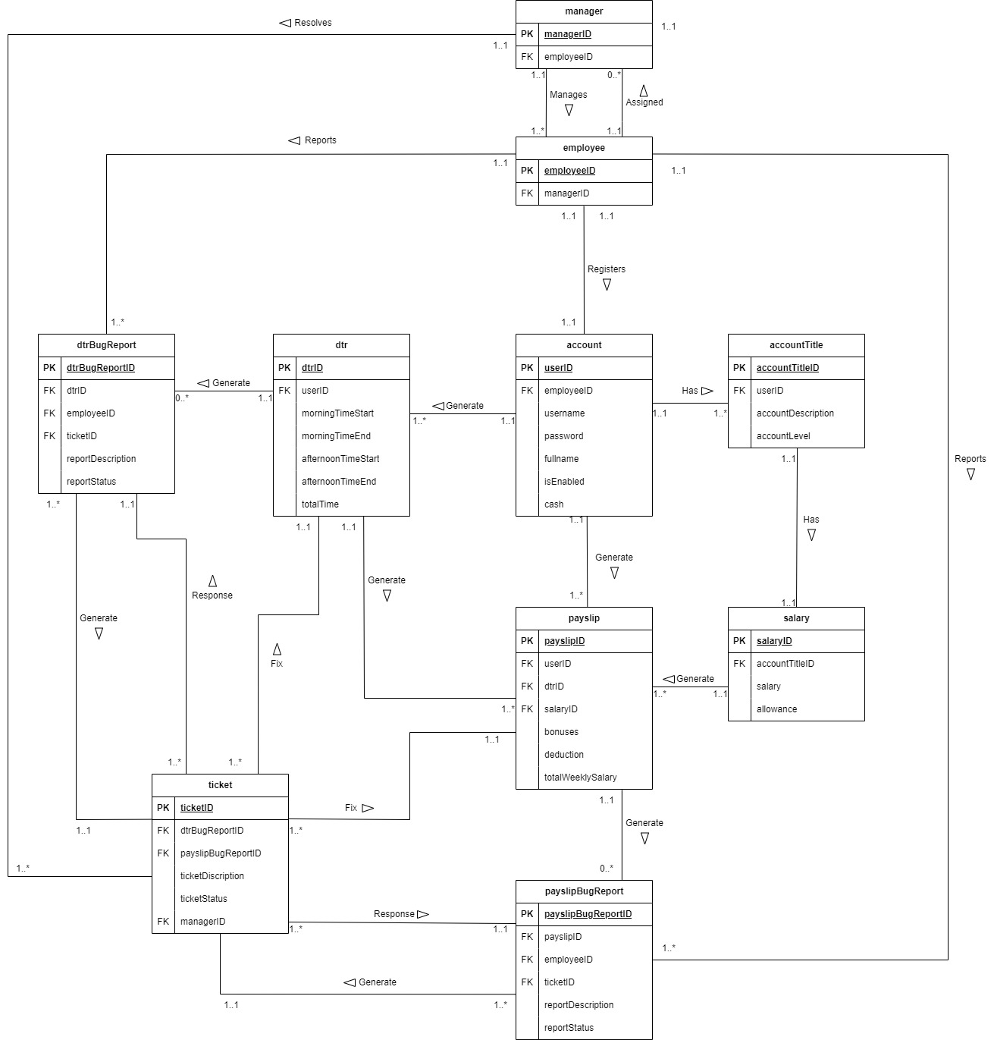

1. **Logical Database Design**

**Final Output Screen**

Login Screen

Ps server

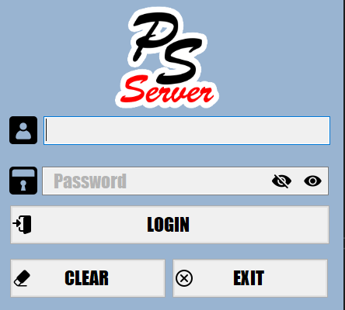

Payroll System

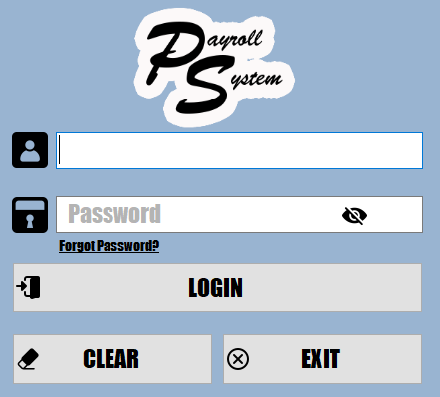

Home Screen

PS Server

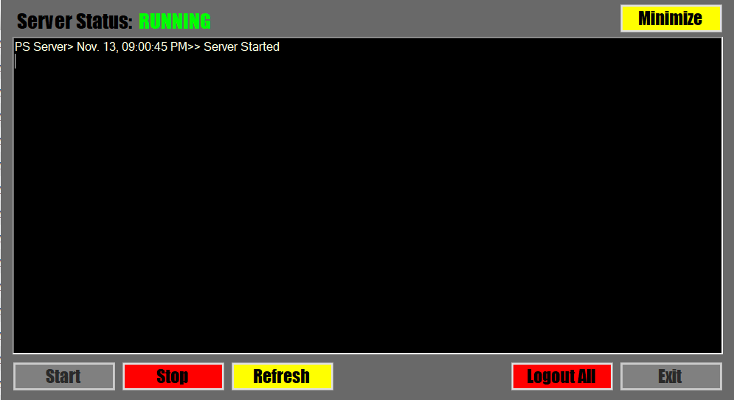

Payroll System

HR

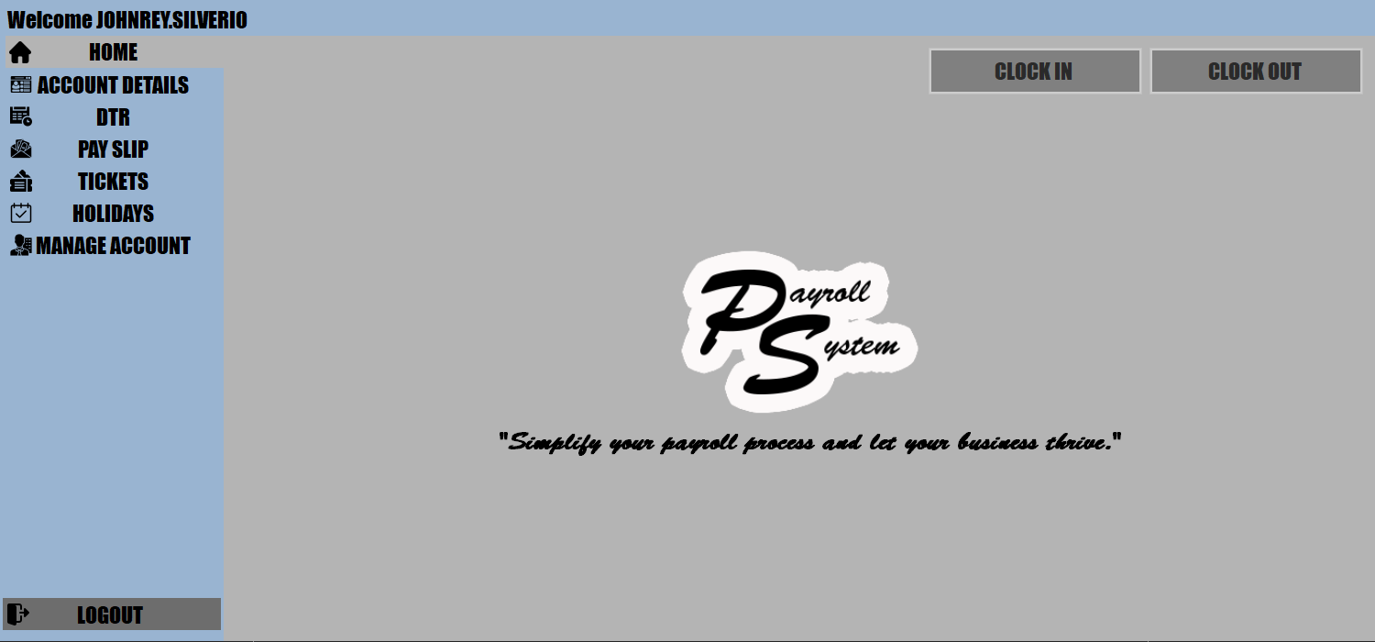

Employees

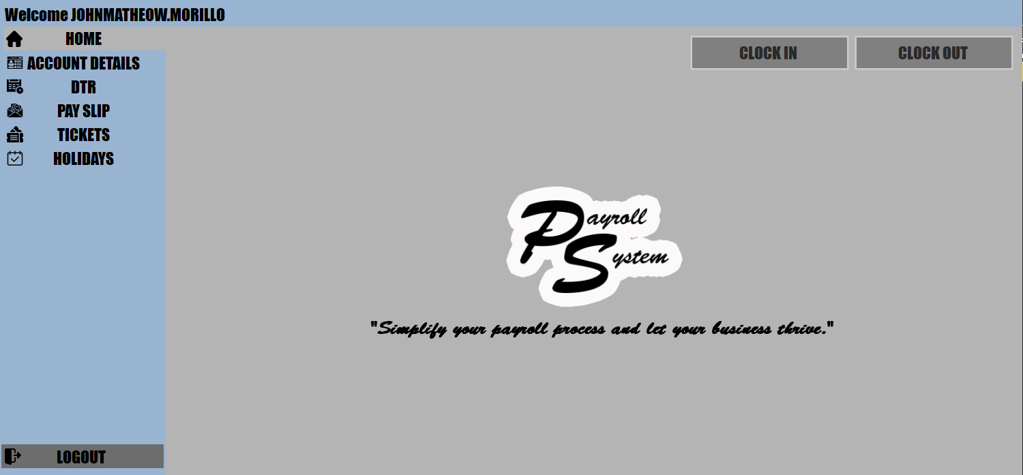

Account Detail

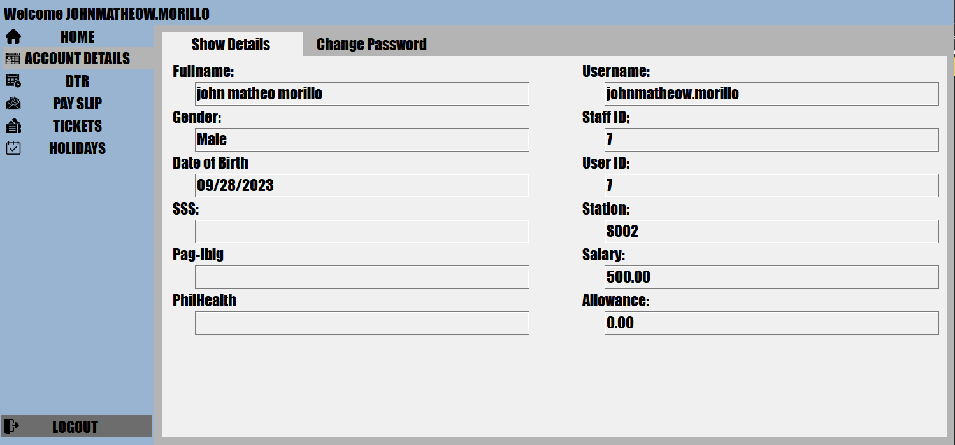

Change Password Screen  
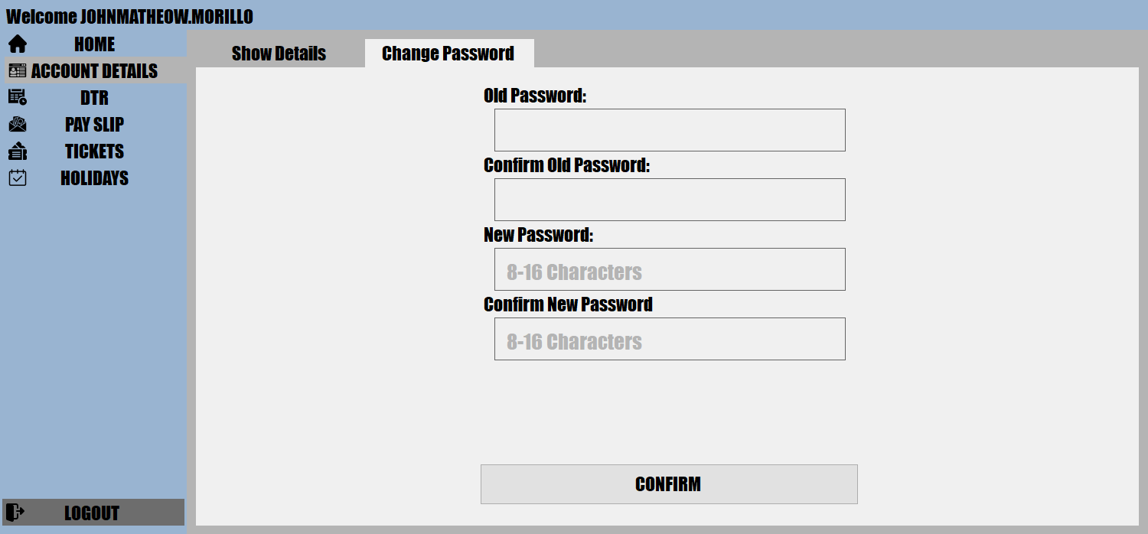

DTR Screen

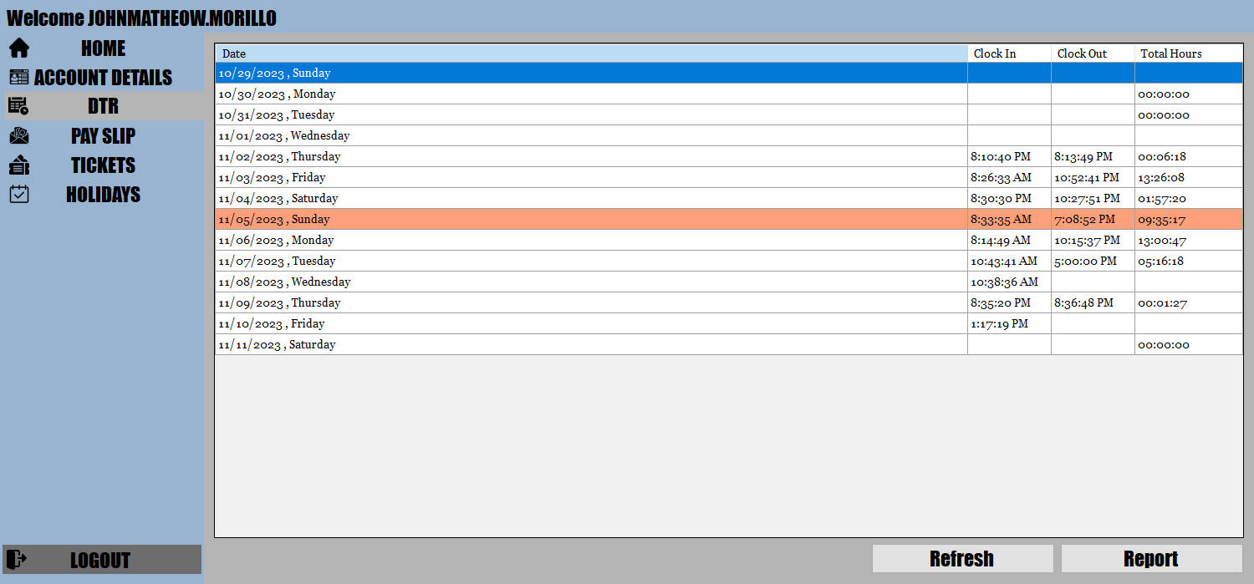

Report DTR

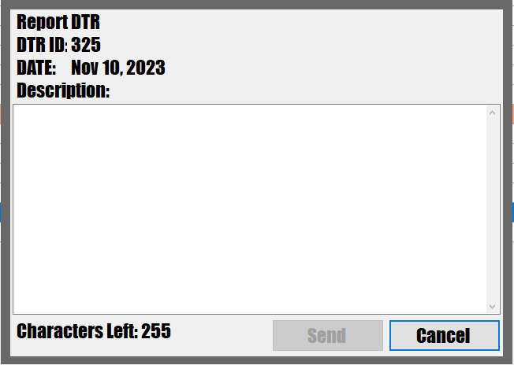

Pay Slip Screen

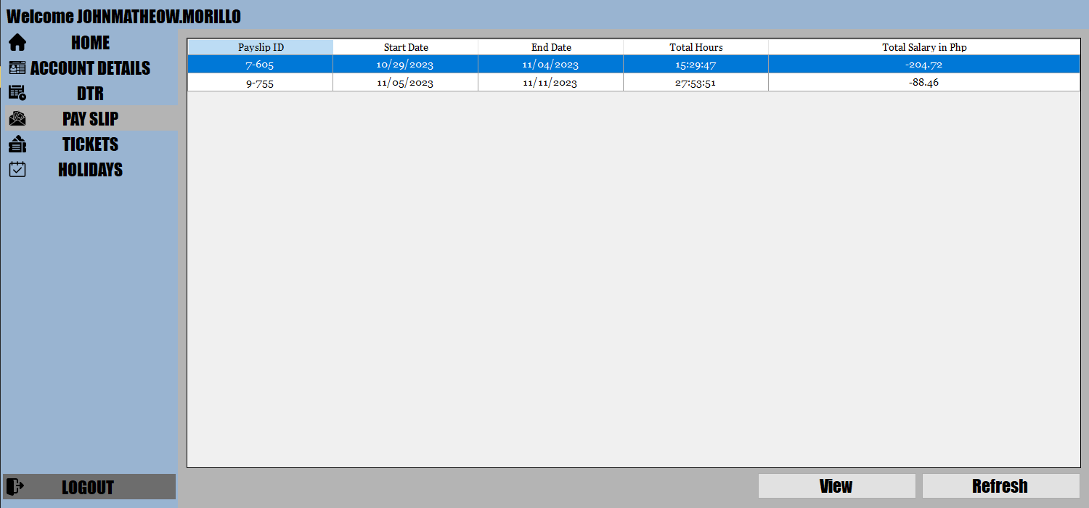

View Specific Pay Slip Screen

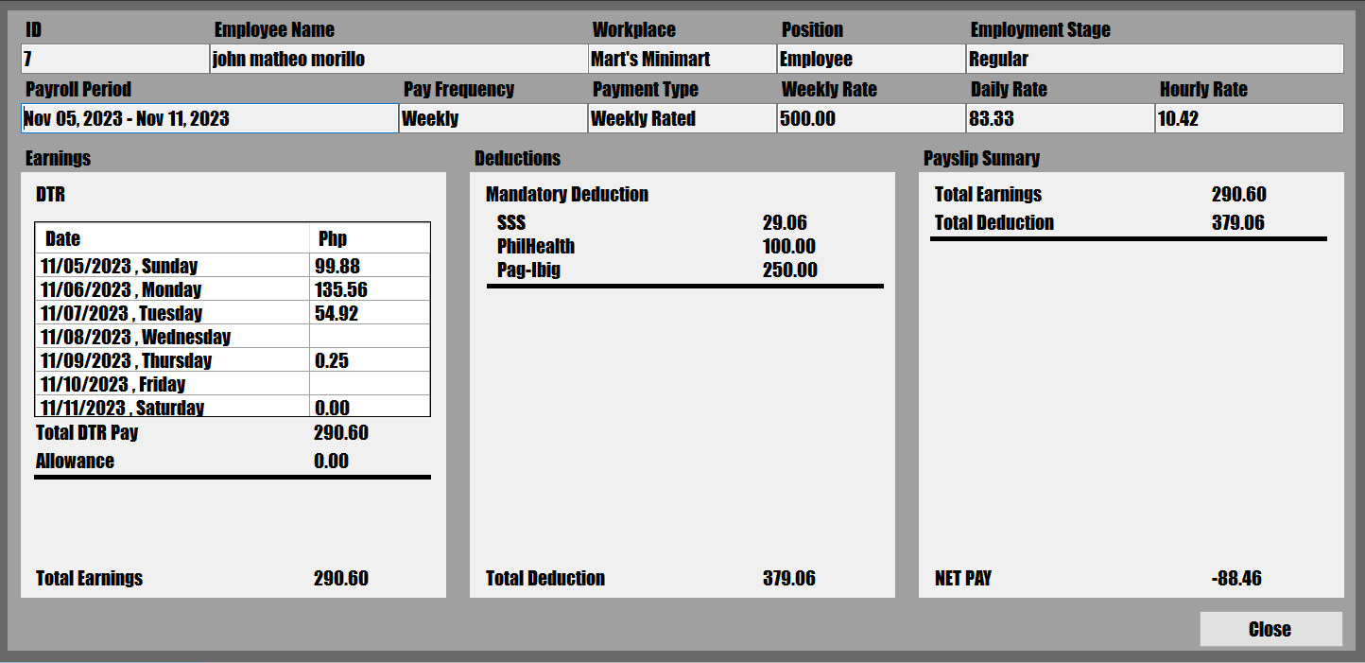

DTR Tickets Screen

HR

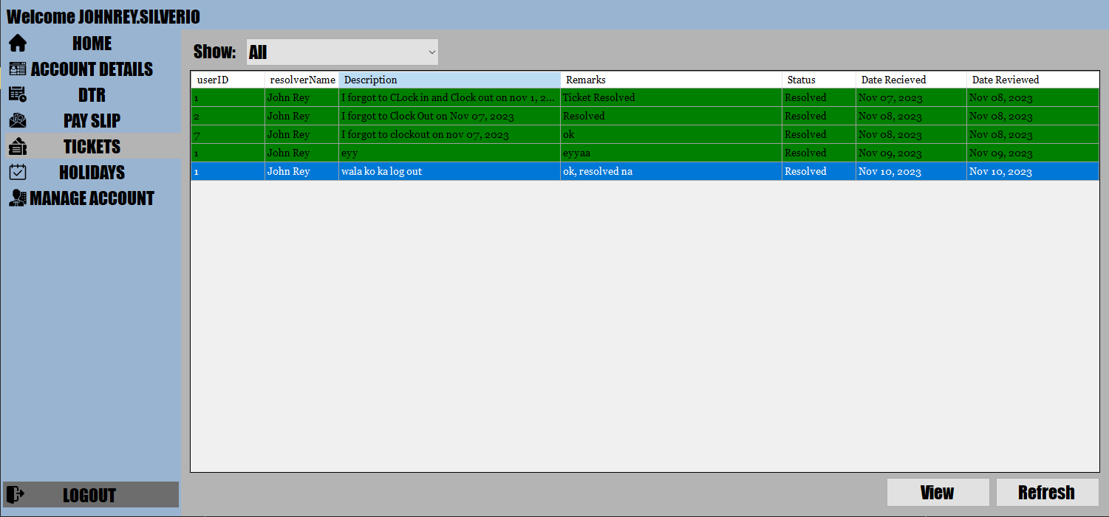

Employee

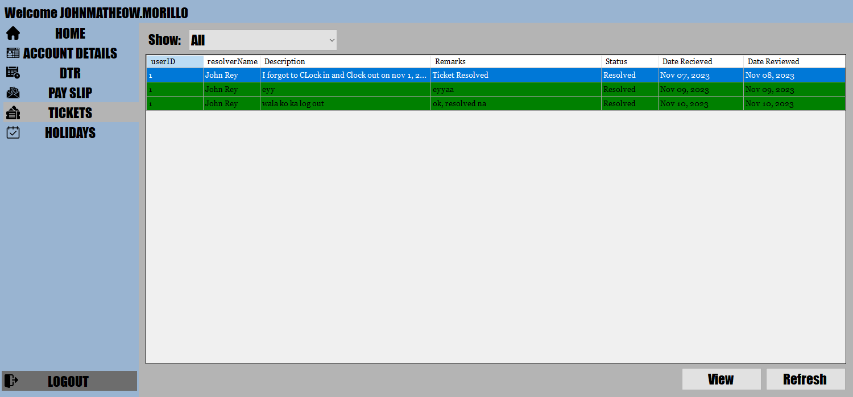

View Specific DTR Ticket  
 HR

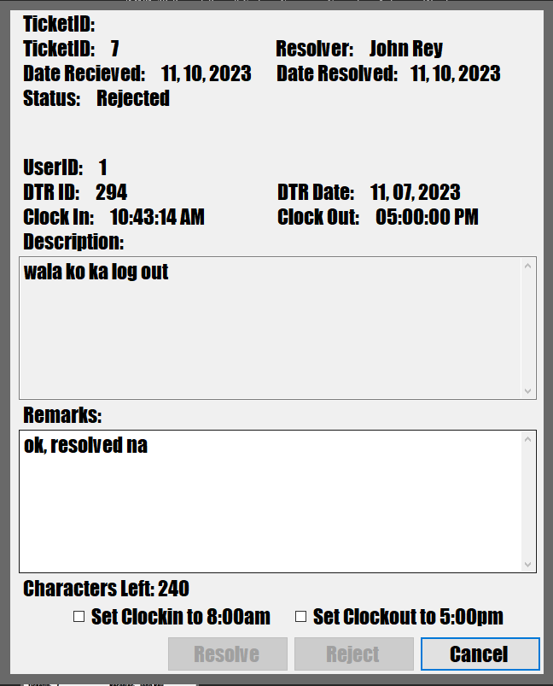

Employee

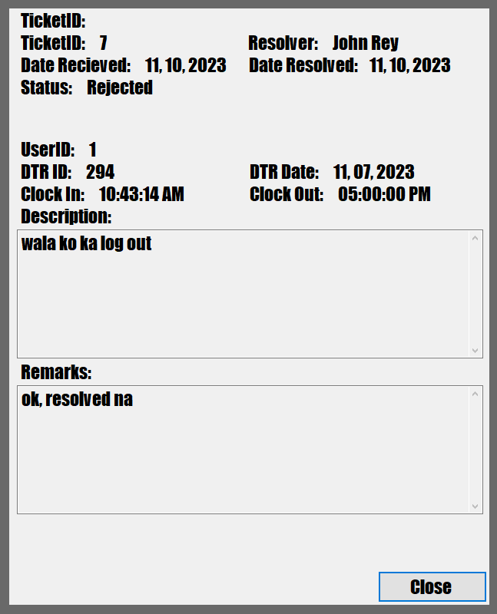

Holidays

HR

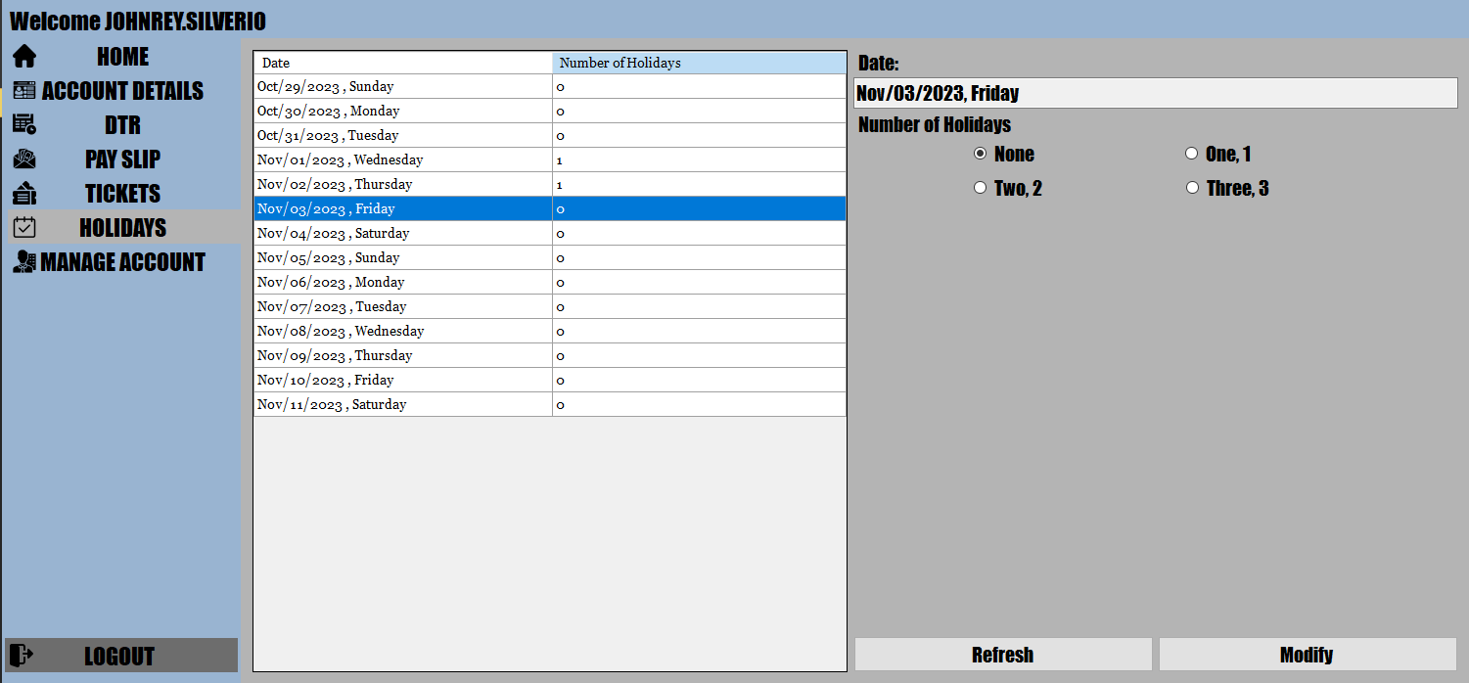

Employee

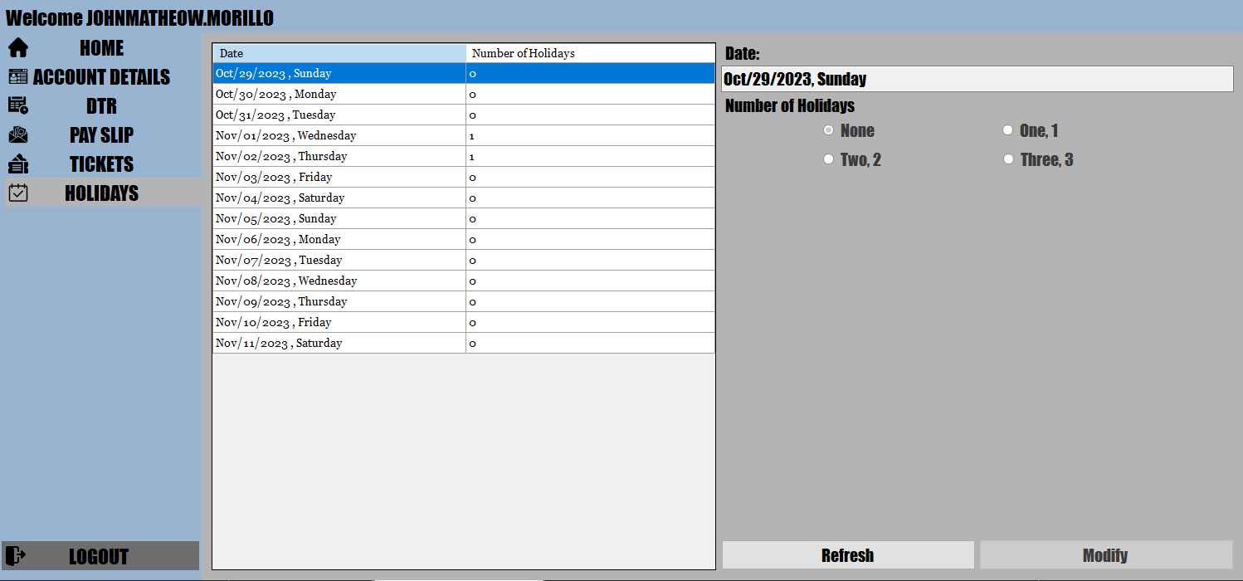

Account Management Screen

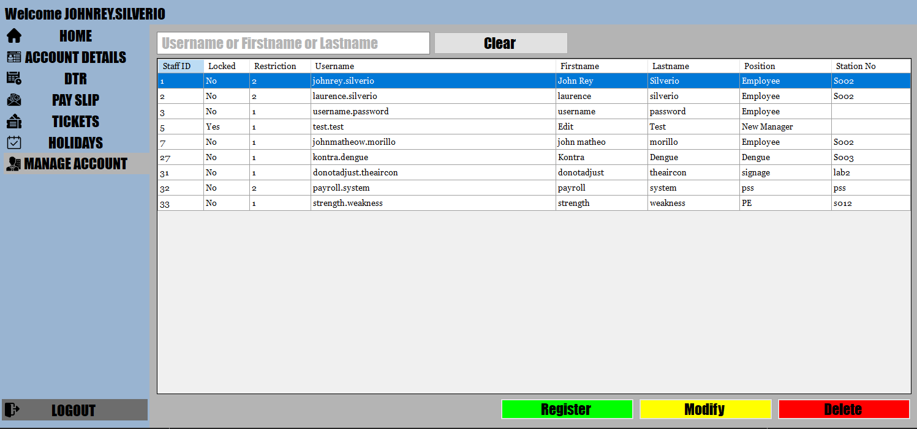

Register Account Screen  
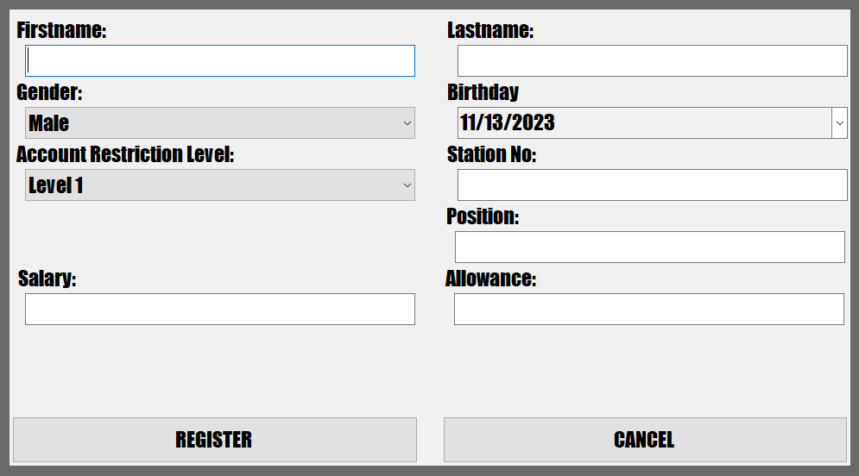

Modify Account Screen

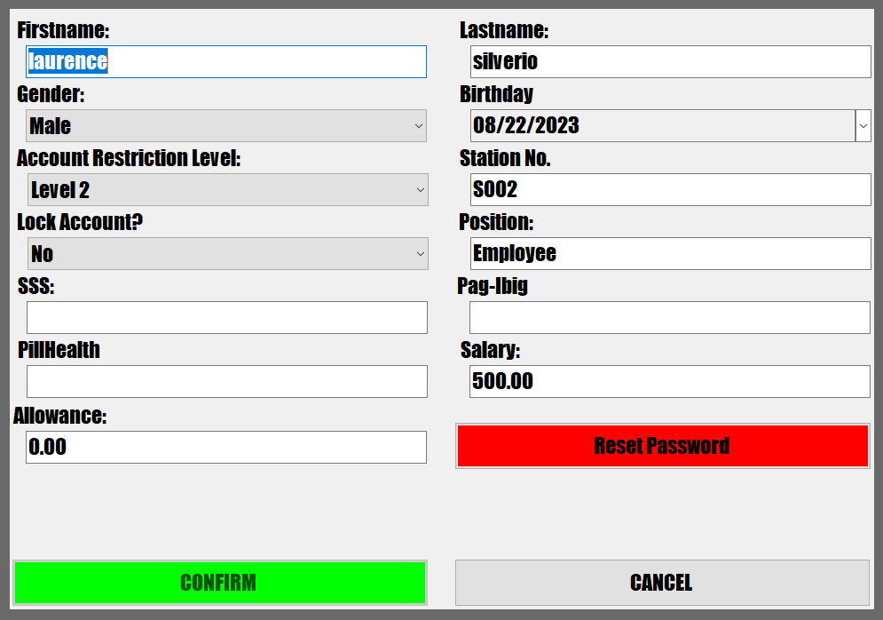

**Final ERD Model**

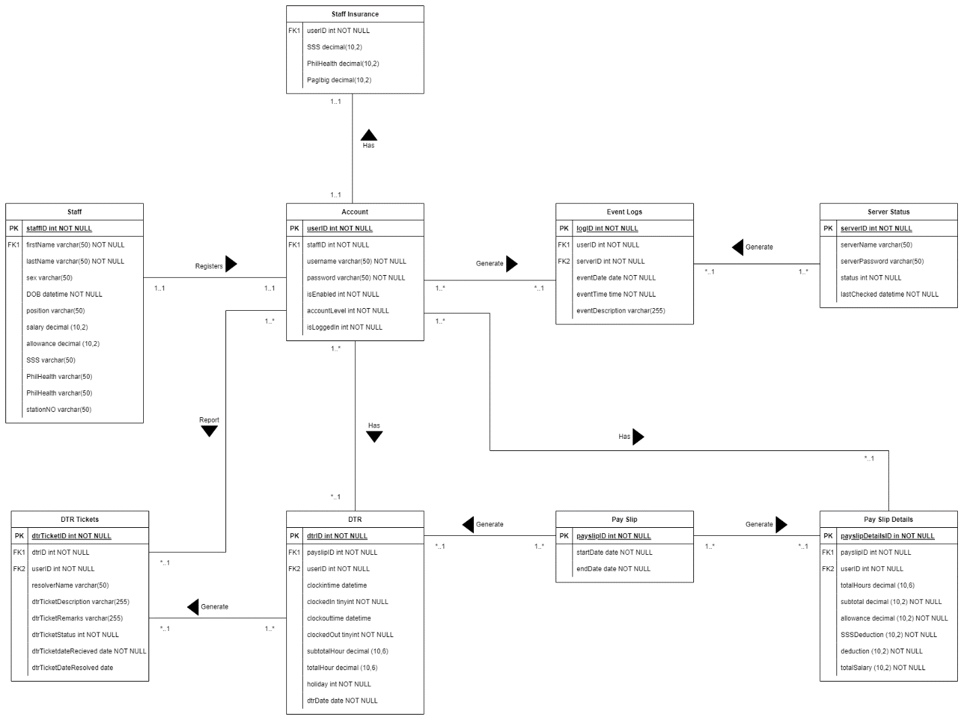

**Final Data Dictionary**

Account

|  |  |  |  |  |  |  |  |  |
| --- | --- | --- | --- | --- | --- | --- | --- | --- |
| Attribute | Description | Type | Size | Null | Unique | Part of PK | Foreign Key | FK Relation |
| userID | User ID | Int |  | No | Yes | Yes | No | DTR, DtrTickets, Staff, payslip detail, event logs |
| staffID | Staff id | Int |  | No | Yes | No | Yes |  |
| username | Username | Varchar | 50 | No | Yes | No | No |  |
| password | Password | Varchar | 50 | No | No | No | No |  |
| isEnabled | Is enabled | Int |  | No | No | No | No |  |
| accountLevel | Account Level | Int |  | No | No | No | No |  |
| isLoggedIn | Is Logged In | Int |  | No | No | No | No |  |

DTR

|  |  |  |  |  |  |  |  |  |
| --- | --- | --- | --- | --- | --- | --- | --- | --- |
| Attribute | Description | Type | Size | Null | Unique | Part of PK | Foreign Key | FK Relation |
| dtrID | DTR ID | Int |  | No | Yes | Yes | No | DtrTickets |
| payslipID | Payslip Id | Int |  | No | Yes | No | Yes |  |
| userID | User ID | Int |  | No | Yes | No | Yes |  |
| clockintime | Clock in time | Datetime |  | Yes | No | No | No |  |
| clockedIn | Clocked In | Int |  | No | No | No | No |  |
| clockouttime | Clock out Time | Datetime |  | Yes | No | No | No |  |
| clockedOut | Clocked Out | Int |  | No | No | No | No |  |
| subtotalHour | Subtotal Hour | Decimal | 10,6 | Yes | No | No | No |  |
| totalHour | Total Hour | Decimal | 10,6 | Yes | No | No | No |  |
| holiday | Holiday | Int |  | No | No | No | No |  |
| dtrDate | DTR Date | Date |  | No | No | No | No |  |

DTR Ticket

|  |  |  |  |  |  |  |  |  |
| --- | --- | --- | --- | --- | --- | --- | --- | --- |
| Attribute | Description | Type | Size | Null | Unique | Part of PK | Foreign Key | FK Relation |
| dtrTicketID | DTR Ticket ID | Int |  | No | Yes | Yes | No |  |
| dtrID | DTR ID | Int |  | No | Yes | No | Yes |  |
| userID | User ID | Int |  | No | Yes | No | Yes |  |
| resolverName | Resolver Name | Varchar | 50 | No | No | No | No |  |
| dtrTicketDescription | DTR Ticket Description | Varchar | 255 | No | No | No | No |  |
| dtrTicketStatus | DTR Ticket Status | Varchar | 255 | No | No | No | No |  |
| dtrTicketDateRecieved | DTR Ticket Date Received | Date |  | No | No | No | No |  |
| dtrTicketDateResolved | DTR Ticket Date Resolved | Date |  | No | No | No | No |  |

Event Log

|  |  |  |  |  |  |  |  |  |
| --- | --- | --- | --- | --- | --- | --- | --- | --- |
| Attribute | Description | Type | Size | Null | Unique | Part of PK | Foreign Key | FK Relation |
| logID | Log ID | Int |  | No | Yes | Yes | No |  |
| userID | User ID | Int |  | No | Yes | No | Yes |  |
| serverID | Server ID | Int |  | No | Yes | No | Yes |  |
| eventDate | Event date | Date |  | No | No | No | No |  |
| eventTime | Event Time | Time |  | No | No | No | No |  |
| eventDescription | Event Description | Varchar | 255 | No | No | No | No |  |

Pay Slip

|  |  |  |  |  |  |  |  |  |
| --- | --- | --- | --- | --- | --- | --- | --- | --- |
| Attribute | Description | Type | Size | Null | Unique | Part of PK | Foreign Key | FK Relation |
| payslipID | Payslip ID | Int |  | No | Yes | Yes | No | DTR, Pay Slip Details |
| startDate | Start Date | Date |  | No | No | No | No |  |
| endDate | End Date | Date |  | No | No | No | No |  |

Pay Slip Detail

|  |  |  |  |  |  |  |  |  |
| --- | --- | --- | --- | --- | --- | --- | --- | --- |
| Attribute | Description | Type | Size | Null | Unique | Part of PK | Foreign Key | FK Relation |
| payslipDetailID | Payslip Detail ID | Int |  | No | Yes | Yes | No |  |
| payslipID | Payslip ID | Int |  | No | Yes | No | Yes |  |
| usrID | User ID | Int |  | No | Yes | No | Yes |  |
| totalHours | Total Hours | Decimal | 10,6 | Yes | No | No | No |  |
| subtotal | Sub Total | Decimal | 10,2 | No | No | No | No |  |
| allowance | Allowance | Decimal | 10,2 | No | No | No | No |  |
| SSSDeduction | SSS Deduction | Decimal | 10,2 | No | No | No | No |  |
| Deduction | Total Deduction | Decimal | 10,2 | No | No | No | No |  |
| totalSalary | Totally Salary | Decimal | 10,2 | No | No | No | No |  |

Server Status

|  |  |  |  |  |  |  |  |  |
| --- | --- | --- | --- | --- | --- | --- | --- | --- |
| Attribute | Description | Type | Size | Null | Unique | Part of PK | Foreign Key | FK Relation |
| serverID | Server ID | Int |  | No | Yes | No | Yes | Event Logs |
| serverName | Server Name | Varchar | 50 | No | Yes | No | No |  |
| serverPassword | Server Password | Varchar | 50 | No | No | No | No |  |
| Status | Server Status | Int |  | No | No | No | No |  |
| lastChecked | Server Last Checked | Datetime |  | No | No | No | No |  |

Staff

|  |  |  |  |  |  |  |  |  |
| --- | --- | --- | --- | --- | --- | --- | --- | --- |
| Attribute | Description | Type | Size | Null | Unique | Part of PK | Foreign Key | FK Relation |
| staffID | Staff ID | Int |  | No | Yes | No | Yes | Account |
| firstName | First Name | Varchar | 50 | No | Yes | No | No |  |
| lastName | Last name | Varchar | 50 | No | No | No | No |  |
| sex | Gender | Varchar | 50 | Yes | No | No | No |  |
| DOB | Date of Birth | DateTime |  | No | No | No | No |  |
| position | Position | Varchar | 50 | No | No | No | No |  |
| salary | Salary | Decimal | 10,2 | Yes | No | No | No |  |
| allowance | Allowance | Decimal | 10,2 | Yes | No | No | No |  |
| SSS | SSS | Varchar | 50 | Yes | Yes | No | No |  |
| PagIbig | Pag-Ibig | Varchar | 50 | Yes | Yes | No | No |  |
| PhilHealth | PhilHealth | Varchar | 50 | Yes | Yes | No | No |  |
| stationNo | Station Number | Varchar | 50 | Yes | No | No | No |  |

Staff Insurance

|  |  |  |  |  |  |  |  |  |
| --- | --- | --- | --- | --- | --- | --- | --- | --- |
| Attribute | Description | Type | Size | Null | Unique | Part of PK | Foreign Key | FK Relation |
| userID | User ID | Int |  | No | Yes | No | Yes |  |
| SSS | SSS | Decimal | 10,2 | No | No | No | No |  |
| PagIbig | Pag-Ibig | Decimal | 10,2 | No | No | No | No |  |
| PhilHealth | PhilHealth | Decimal | 10,2 | No | No | No | No |  |

**Final Normalized Tables**

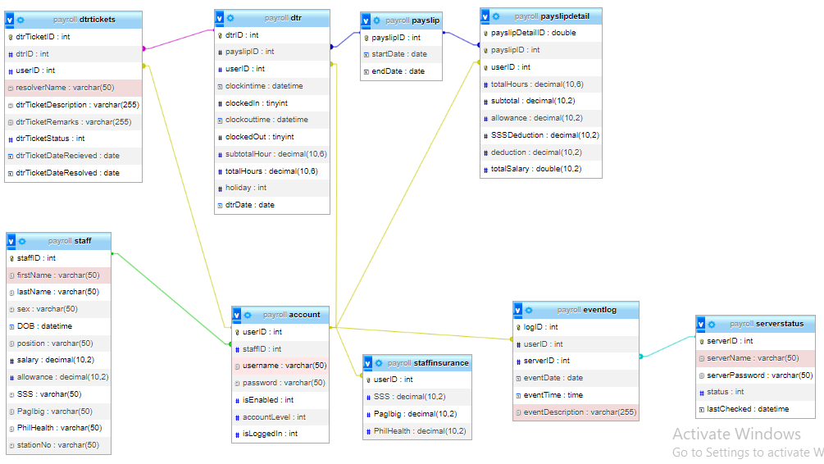

1. **Physical Database Design**

**Indexes**

1. Create Unique Clustered Index for Primary Keys

|  |  |  |
| --- | --- | --- |
| Entity | Primary Key Attribute | Index Name |
| account | userID | Primary |
| dtr | dtrID | Primary |
| dtrtickets | dtrTicketId | Primary |
| eventlog | logID | Primary |
| payslip | payslipID | Primary |
| payslipdetail | payslipDetailID | Primary |
| serverstatus | serverID | Primary |
| staff | staffID | Primary |

1. Create Index for Non-Key Indexes

|  |  |  |
| --- | --- | --- |
| Entity | Primary Key Attribute | Index Name |
| staff | firstName | firstName\_Index |
| staff | SSS | SSS |
| staff | PagIbig | PagIbig |
| staff | PhilHealth | PhilHealth |

**Integrity Constrains**

Referential Integrity

* HR and Staff - Cascade Constraints
  + An HR can alter the staff’s details.
  + An HR can register an staff’s account
* Staff and Account – Cascade Constraints
  + A Staff will always have his own unique staff ID and account ID.
  + staff have certain account levels that restrict their power.
  + Level 1 = Lowest; it can only modify his own account password and submit a DTR tickets
  + Level 2 = It can modify accounts under. It can also register a staff. It can also resolve DTR Tickets
* Account and DTR – Cascade Constraints
  + An account will automatically generate a DTR, whether he/she is online or not.
  + An account can also report a problem with his/her own DTR.
* Account and Pay Slip – Cascade Constraints
  + An account will automatically generate a pay slip whether he/she is online or not.
* DTR and Pay Slip – Cascade Constraints
  + A DTR is not necessarily needed to produce pay slips.
* DTR and DTR Tickets
  + If an account reports a DTR, it will send a ticket.
  + DTR tickets can only be resolved by a Level 2 account.

**Transaction Map**

Calculating DTR Subtotal Hour

Input Clock Out

Process Subtotal Hour

Input Clock in

Calculating DTR Total Hour

Process Total Hour

Get Number of Holiday

Get Subtotal Hour

Calculate Pay Slip Detail Total Hour

Process Pay Slip Detail Total Hour

Get DTR Total Hour

Calculate Pay Slip Subtotal

Get Pay Slip Detail Total Hour

Get Hourly Rate

Process Pay Slip Detail Subtotal

Calculate Pay Slip SSS Deduction

Process Pay Slip Detail SSS Deduction

Get Pay Slip Detail Subtotal

Get SSS Deduction

Calculate Pay Slip Total Deduction

Get Pay Slip Detail SSS Deduction

Get Pag-Ibig and PhilHealth Deduction

Process Total Deduction

Calculate Pay Slip Total Salary

Get Subtotal

Get Total Deduction

Process Total Salary

1. **Curriculum Vitae**



**John Rey J. Silverio**

**Age**: 21

**Civil Status**: Single

**Home Address**: Purok 1-B Sitio Maag, Peñaplata District 2 **Birthdate**: April 17, 2001

**City Address**: Island Garden City of Samal, Davao Del Norte **Religion**: Roman Catholic

**CONTACT INFORMATION**

|  |  |
| --- | --- |
| C:\Users\Admin\Documents\Cora\download.png | johnrey.silverio.p@gmail.com |
| C:\Users\Admin\Documents\Cora\img_500612.png | 0930-629-7787 |

**PERSONAL DATA**

Father’s Name : Reynaldo H. Silverio Jr

Occupation : Laborer

Citizenship : Filipino

Mother’s Name : Cecilla J. Silverio

Occupation : Teacher

Citizenship : Filipino

Language/Dialect Spoken: English, Filipino & Bisaya

**EDUCATIONAL BACKGROUND**

**TERTIARY Holy Cross of Davao City** Sta. Ana, Davao City, Davao Del Sur

Bachelor of Science in Information Technology

School Year 2021 – Current

**SECONDARY** **Samal Señor High School**

Peñaplata, IGACOS, Davao Del Norte

School Year 2017-2019

**Samal National High School**

Peñaplata, IGACOS, Davao Del Norte

School Year 2013-2017

**ELEMENTARY**  **Peñaplata Central Elementary School**

Peñaplata IGACOS, Davao Del Norte

School Year 2007-2013

**COMMUNITY & WORK EXPERIENCES**

* **Part Time Job - Cashier**

Mart’s Minimart

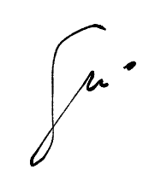2021 – Current

**Silverio, John Rey J.**

Signature Over Printed Name



**John Mathew Morillo**

**Age**: 20

**Civil Status**: Single

**Home Address**: 79 C Arellano Street **Birthdate**: May 27, 2003

**City Address**: Davao City, Davao Del Sur **Religion**: Roman Catholic

**CONTACT INFORMATION**

|  |  |
| --- | --- |
| C:\Users\Admin\Documents\Cora\download.png | Johnmatthewmorillo58@gmail.com |
| C:\Users\Admin\Documents\Cora\img_500612.png | 0995-210-8138 |

**PERSONAL DATA**

Father’s Name : Marciano Morillo

Occupation : Company Driver

Citizenship : Filipino

Mother’s Name : Ma. Corazon Morillo

Occupation : Teacher

Citizenship : Filipino

Language/Dialect Spoken: English, Filipino & Bisaya

**EDUCATIONAL BACKGROUND**

**TERTIARY Holy Cross of Davao City** Sta. Ana, Davao City, Davao Del Sur

Bachelor of Science in Information Technology

School Year 2021 – Current

**SECONDARY** **Davao City National High School**

F. Torres St. Davao City

School Year 2019-2021

**Davao City National High School**

F. Torres St. Davao City

School Year 2015-2019

**ELEMENTARY University of Mindanao Matina Campus**

Matina, Davao City, Davao Del Sur

School Year 2009-2015

**COMMUNITY & WORK EXPERIENCES**



* **Training Attended**

NCII (2019)

**Morillo, John Matthew**

Signature Over Printed Name